# Spatial analysis

## Creating interactive maps

### Creating a map and selecting a provider

|  |  |
| --- | --- |
|  | Graphical user interface, text  Description automatically generated  "CartoDB","Esri","CartoDB.PositronNoLabels" |

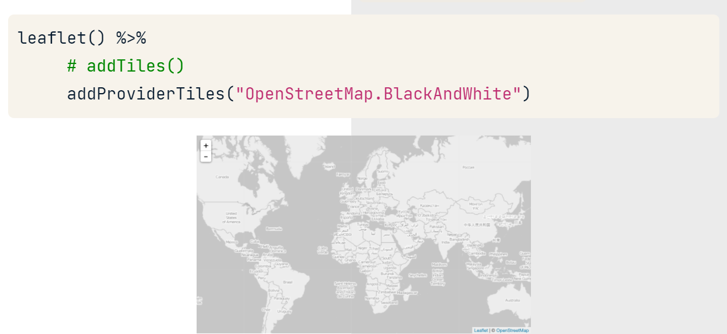

### Dynamic provider selector

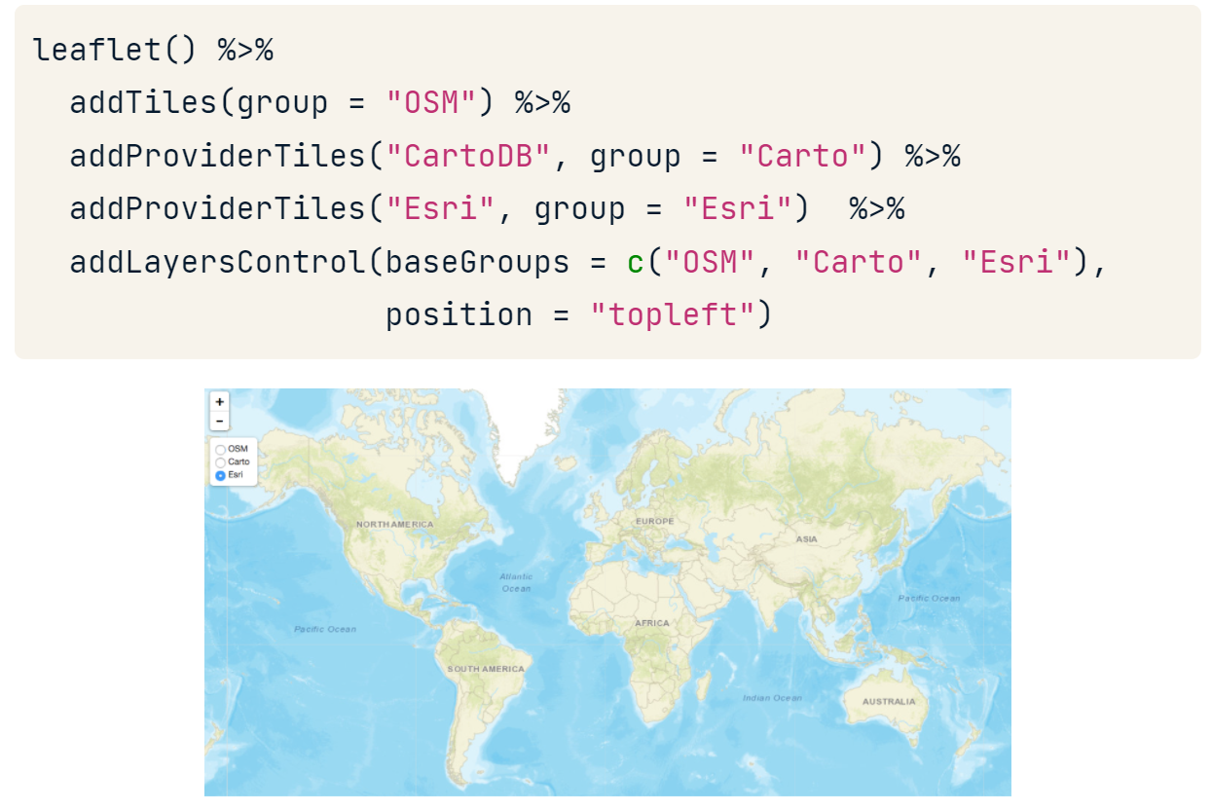

### Adding a blue mark and message from vectors

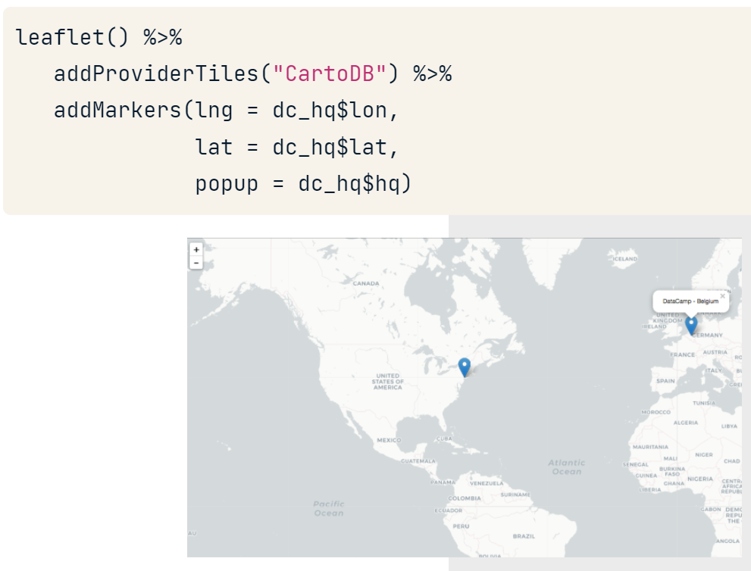

### Setting popups design

**htmlwidgets::htmlEscape()** function will sanitize characters that may be interpreted as HTML.

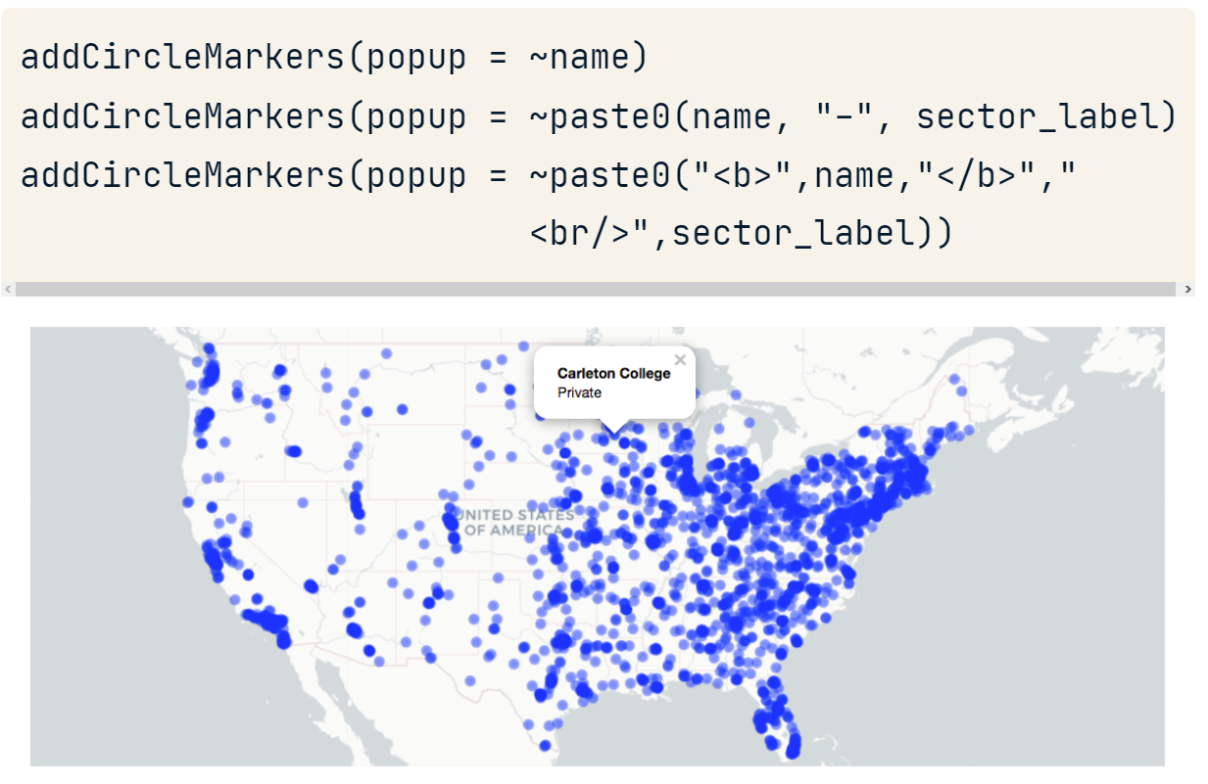

### Getting a position from a direction

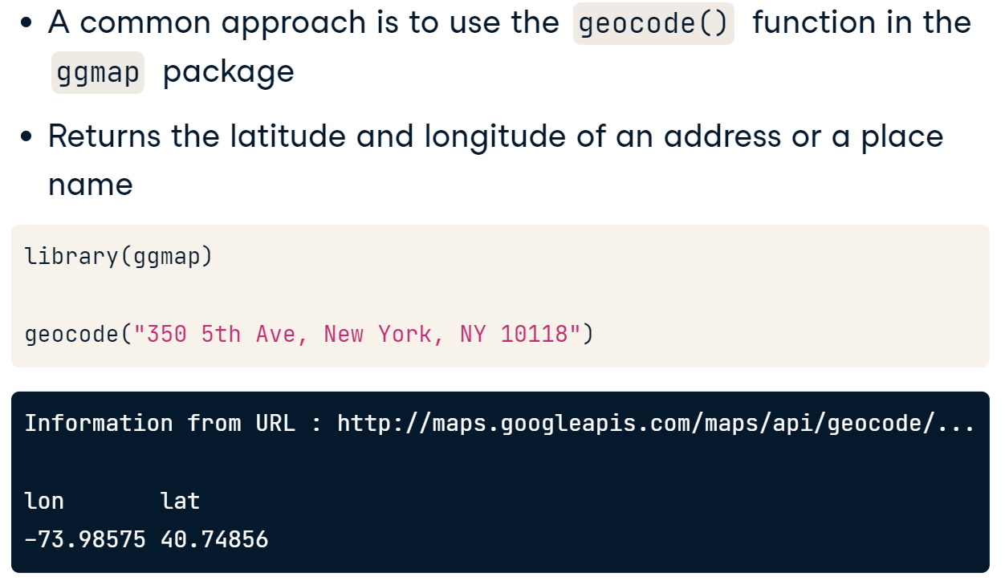

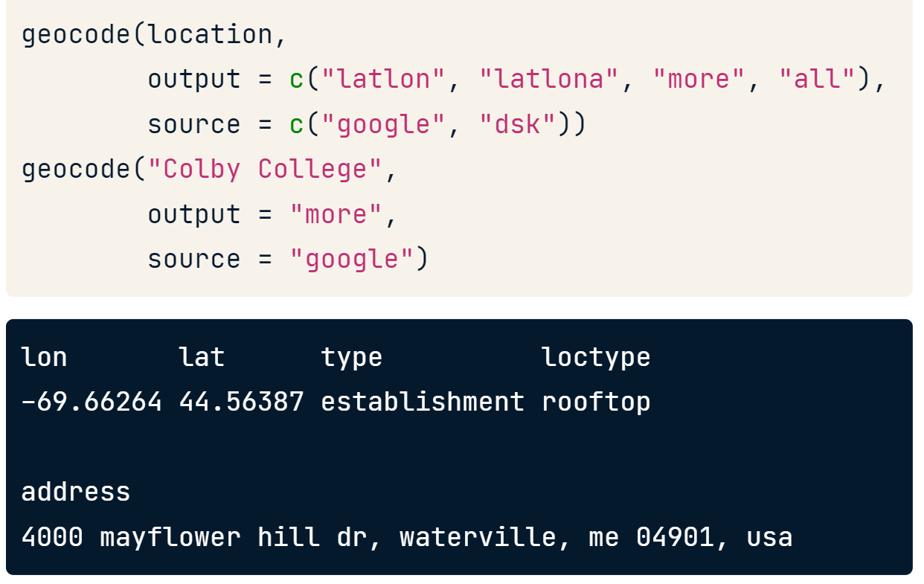

### Getting a direction from a position

library(tmaptools)

rev_geocode_OSM(x=lon, y=lat,as.data.frame = TRUE)

# the direction is the column “names"

### Selecting a position and zoom in the map

In **setView()** we need to specify the center of the view with lat and log.

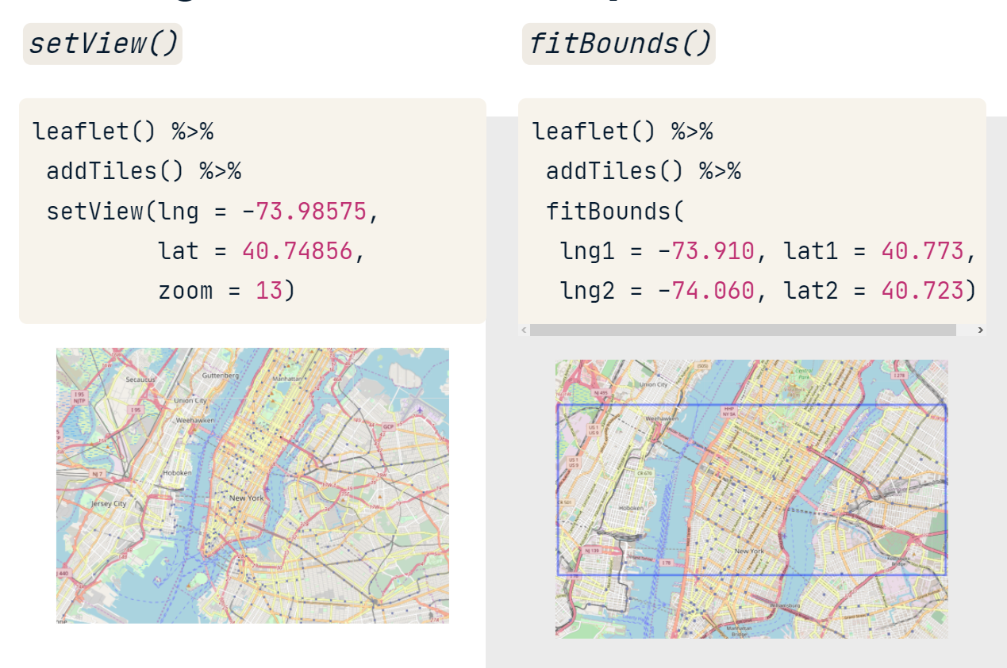

### Limiting the map view

#### Fixing the map in a view

Switching dragging to FALSE will prevent panning and setting the min and max zoom arguments will limit the zoom, effectively setting and maintaining the focal point, while preserving the interactive features of our web map.

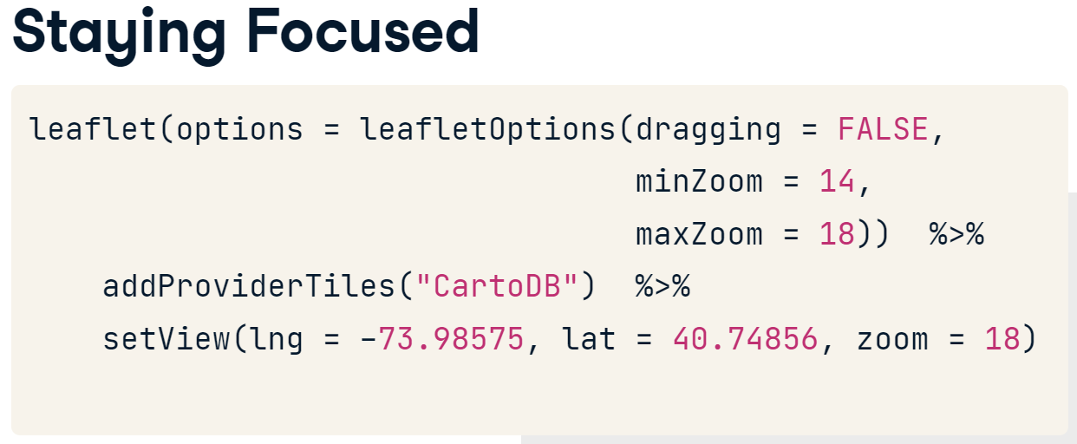

#### Taking back the user to original position

If users try to pan your map outside of the max bounds they will be automatically bounced back into the boundary.

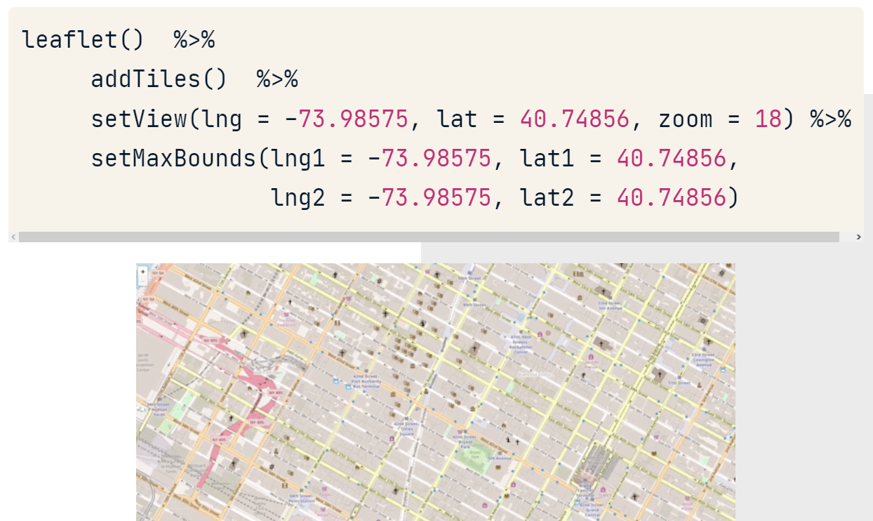

### Taking out the boundaries and markers

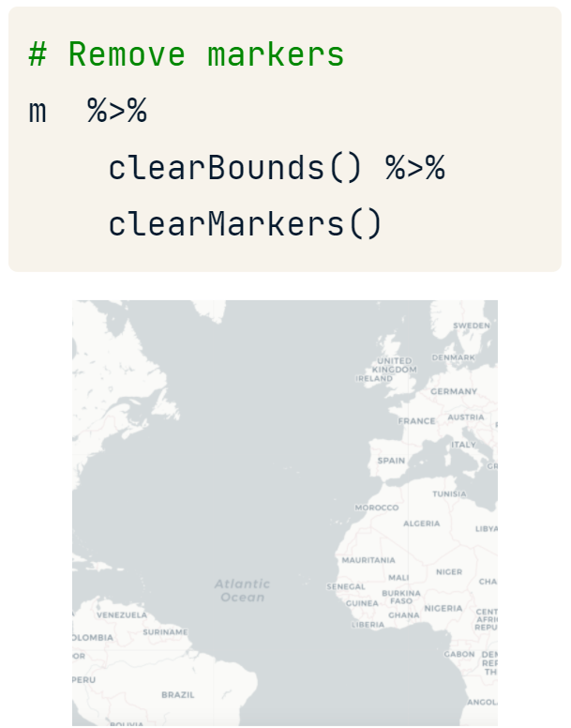

### Adding a circle and message from a dataframe

|  |  |
| --- | --- |
|  |  |

#### Changing points’ color

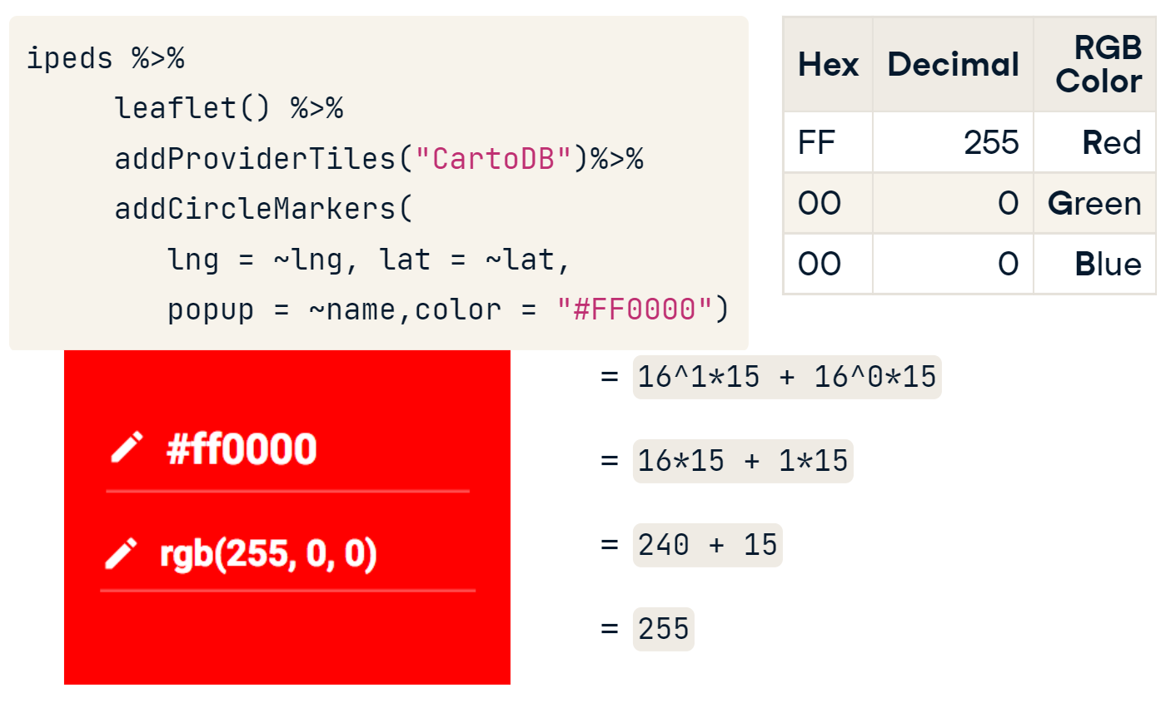

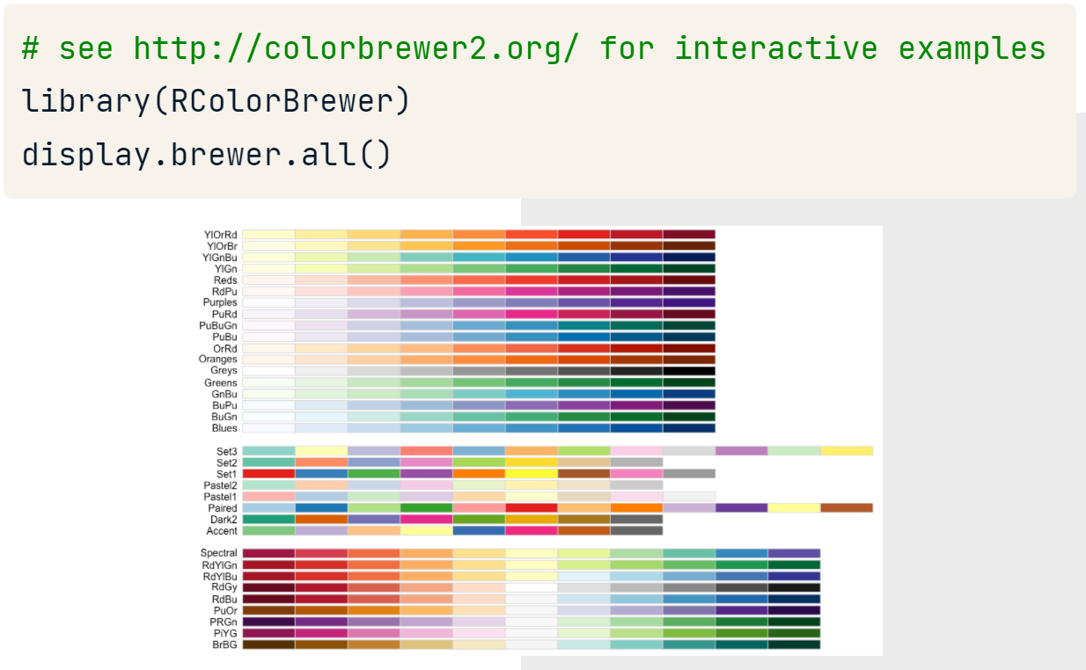

#### Adding a static legend for categorical data

**colorFactor()** creates a function to relate color and levels.

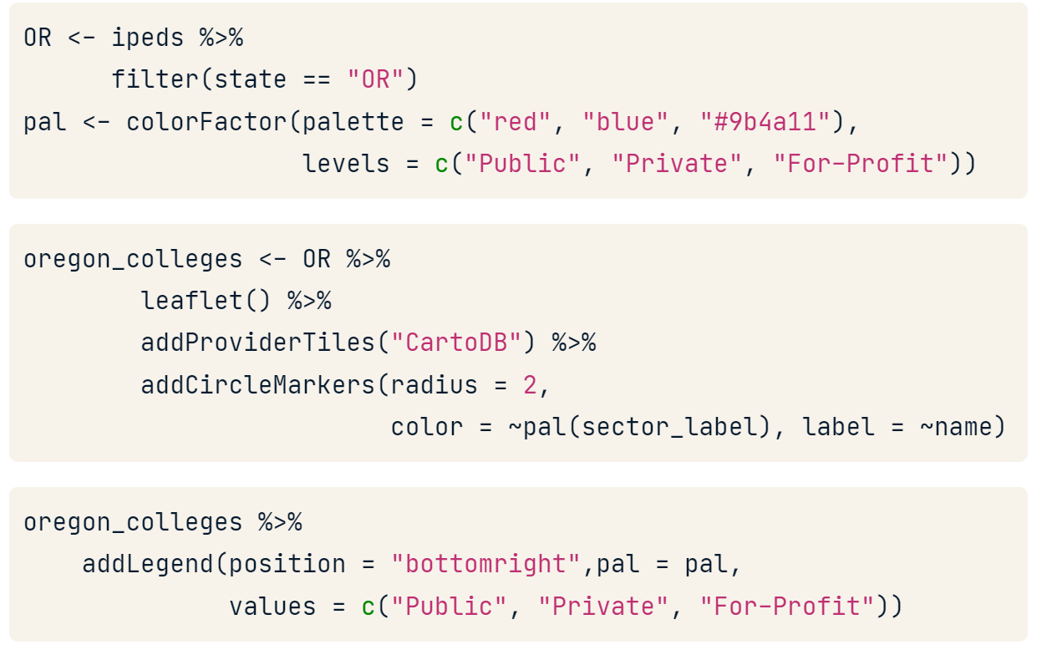

#### Adding a dynamic legend for categorical data

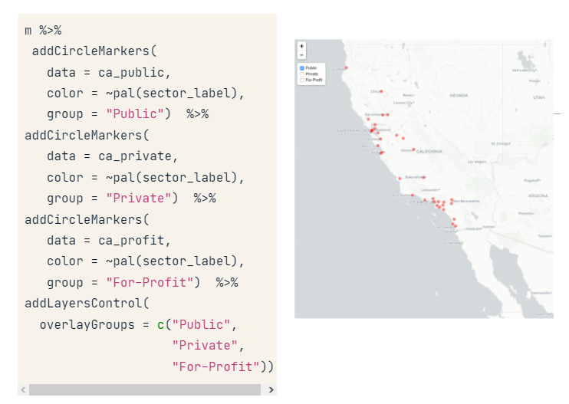

#### Adding a static legend for numerical data

**colorNumeric()** creates a function to relate color and numbers.

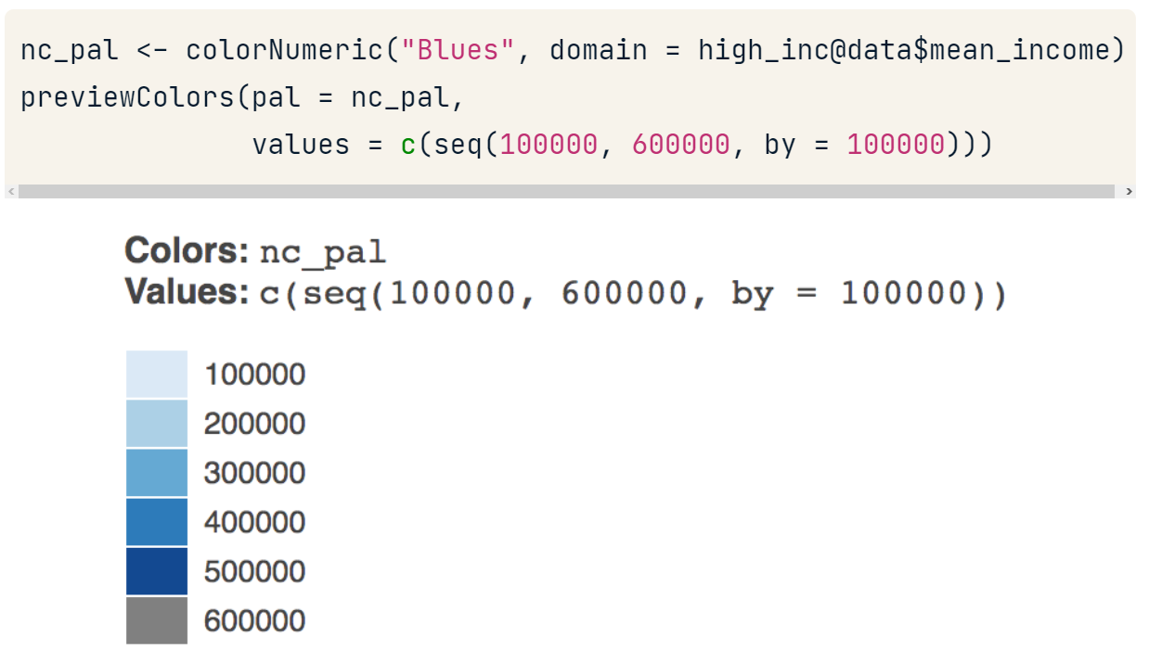

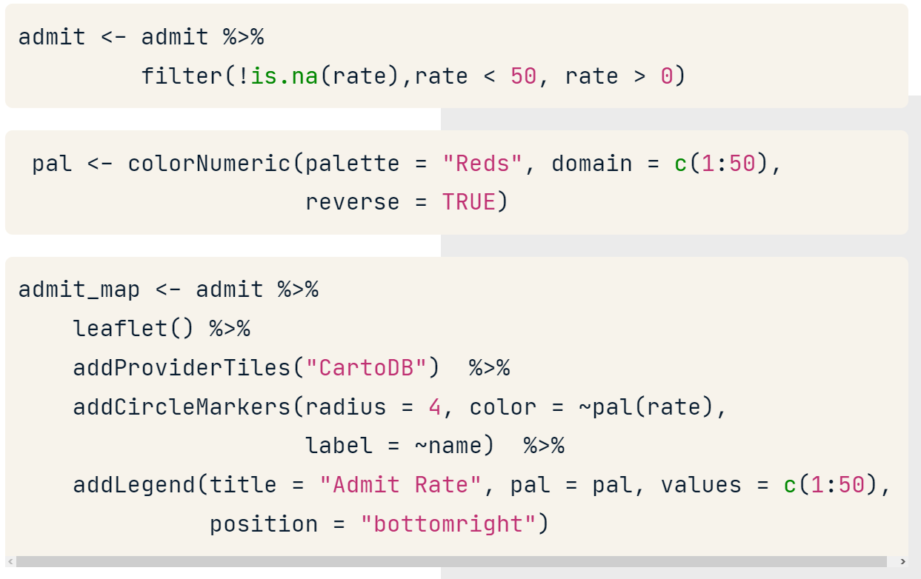

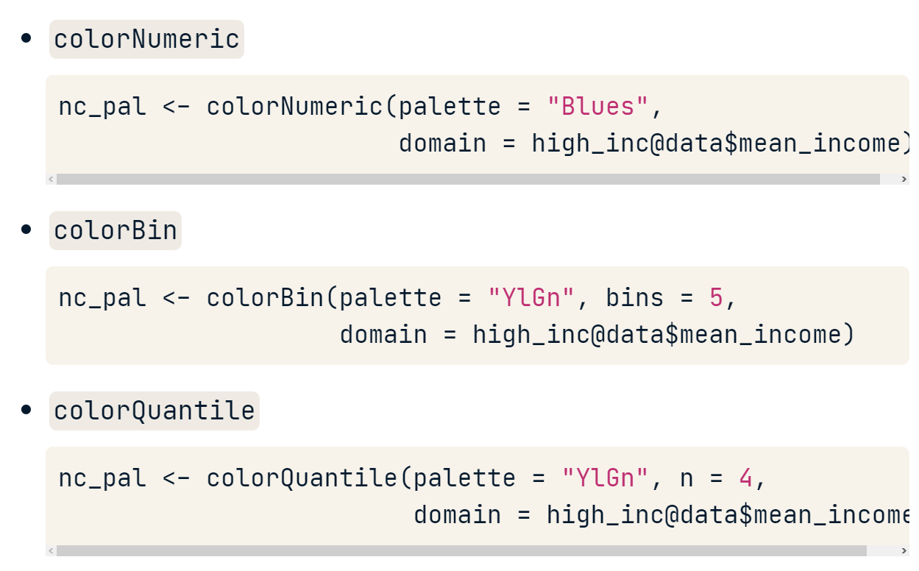

### Setting dynamic provider and legend

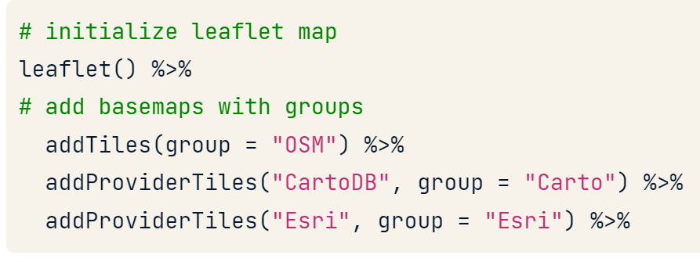

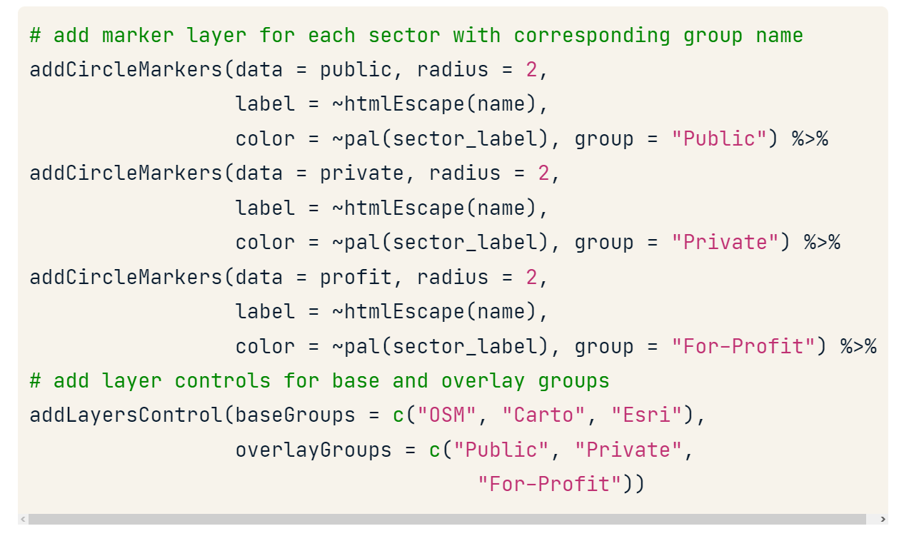

### Group many circles in clusters

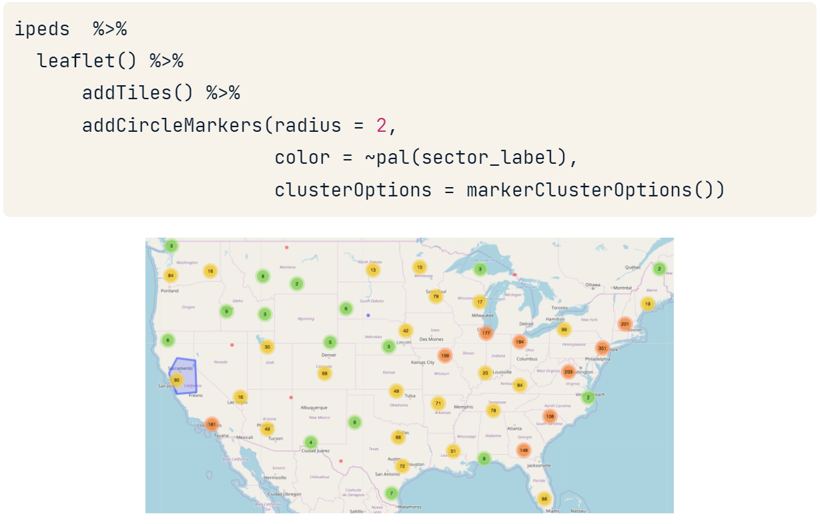

### leaflet.extras Package

#### Adding a general search bottom

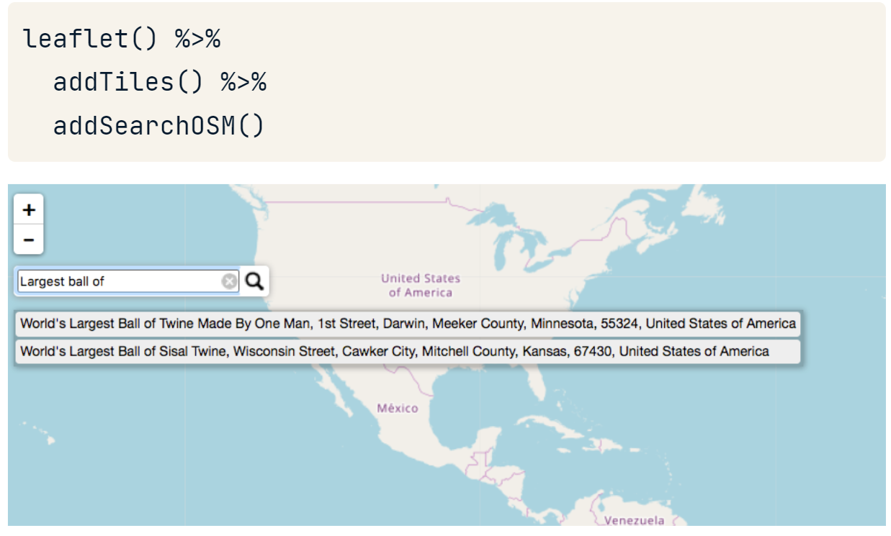

#### Adding a search bottom for our data

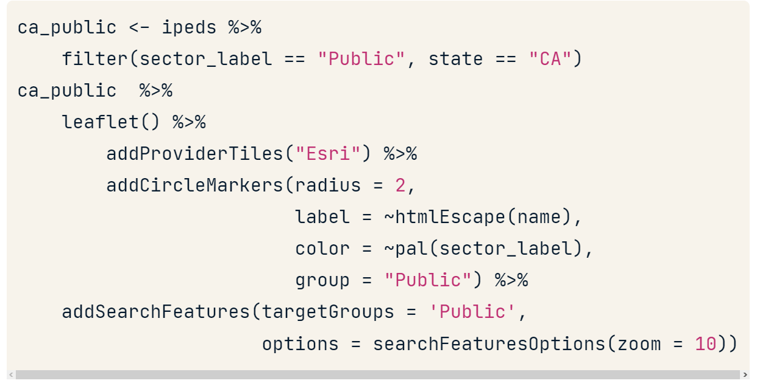

#### Adding a reset position bottom

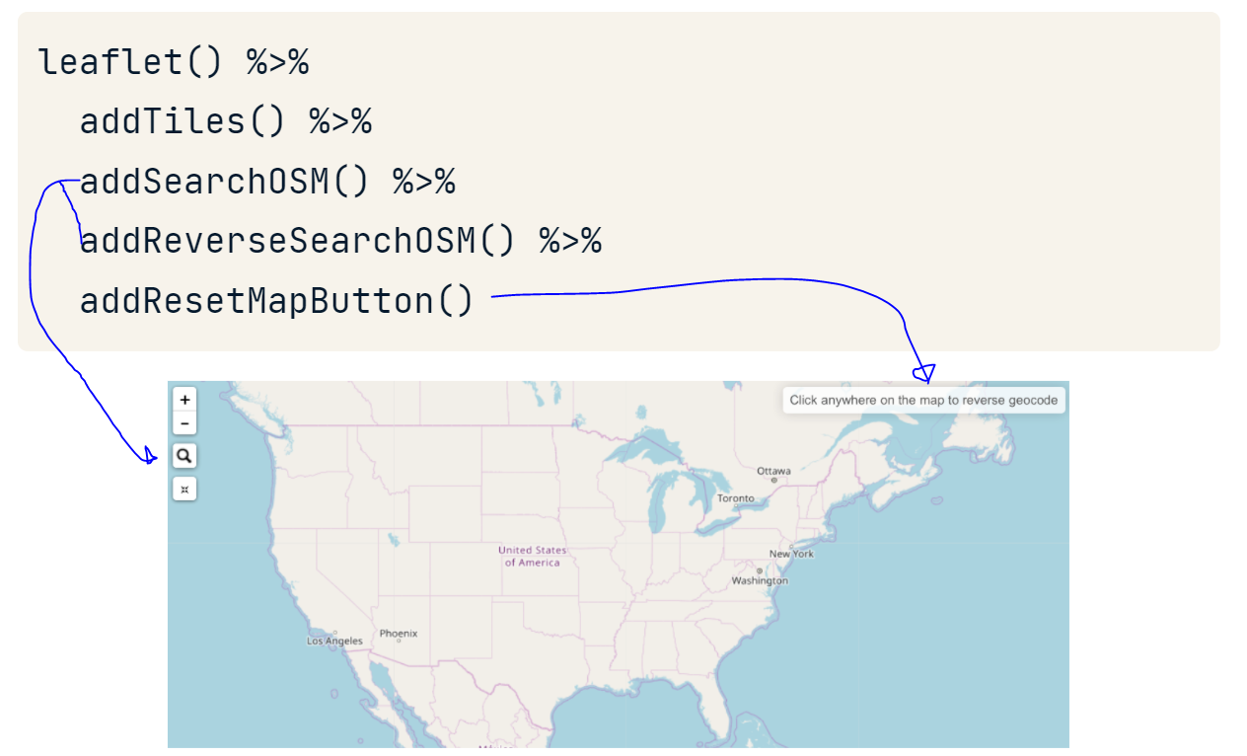

### Adding polygons to our map

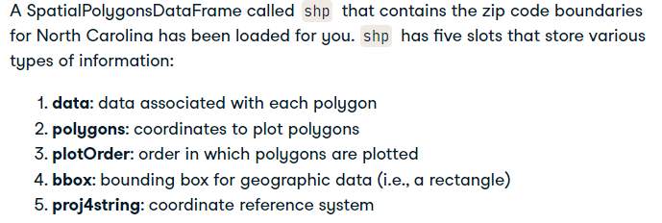

slotNames(shp): shows the names

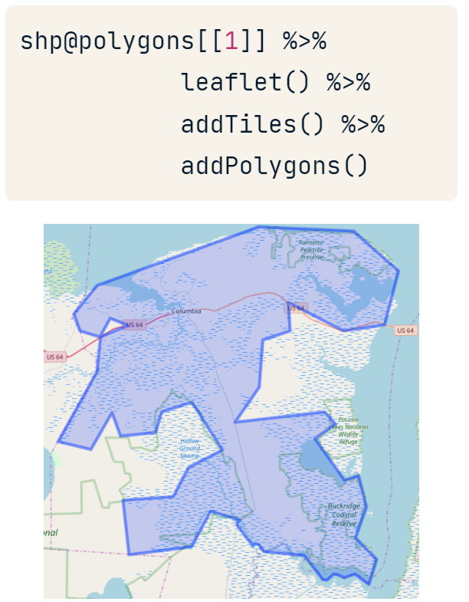

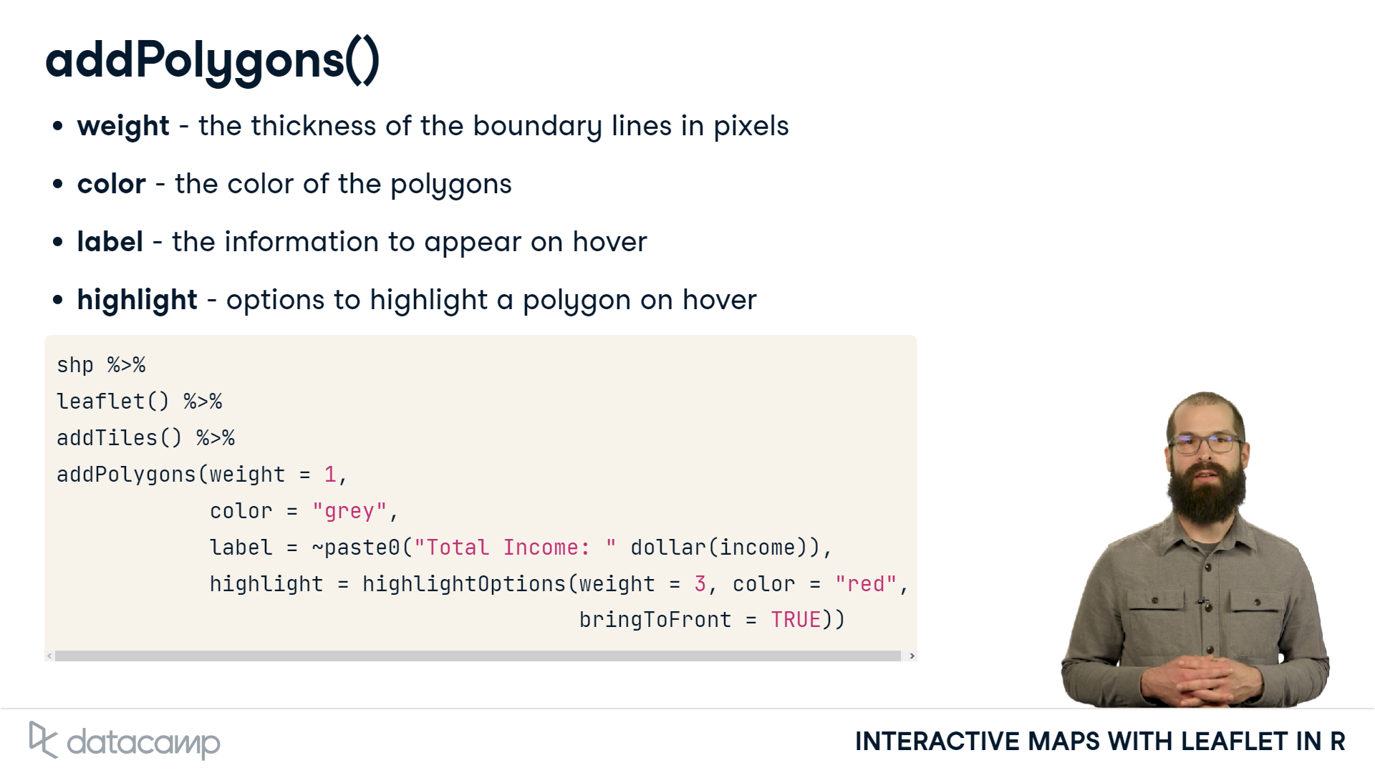

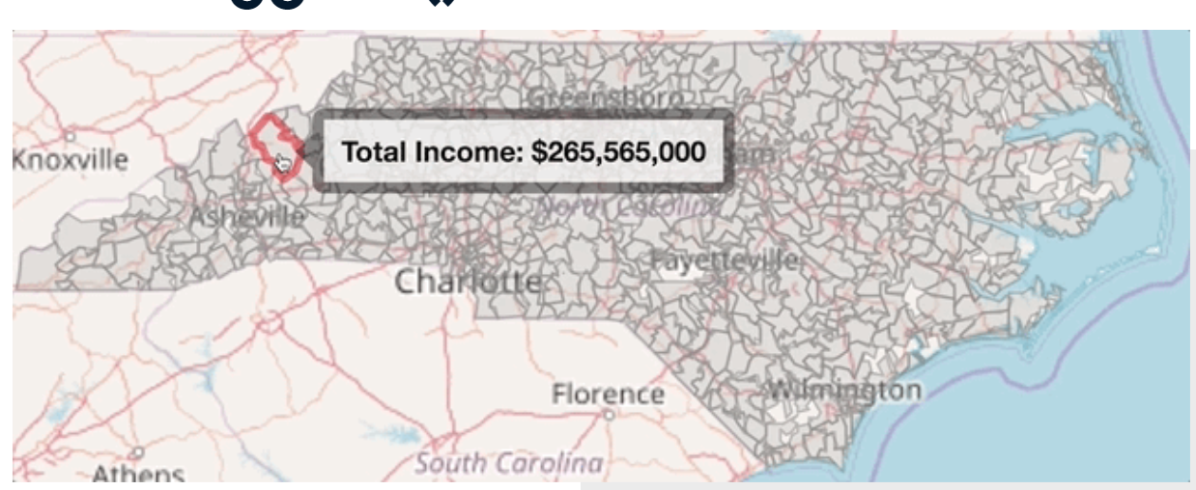

Now let’s use palette color

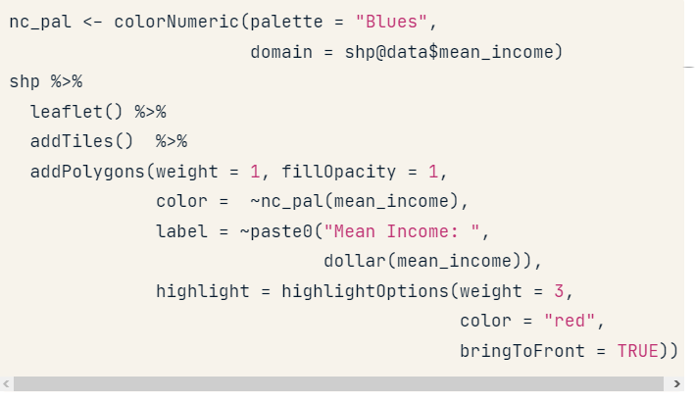

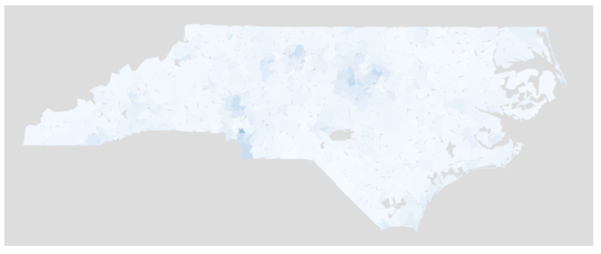

### Let’s see all together

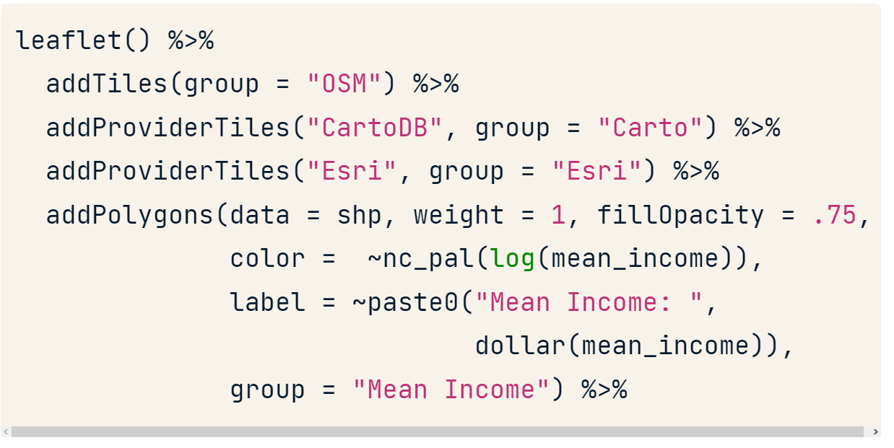

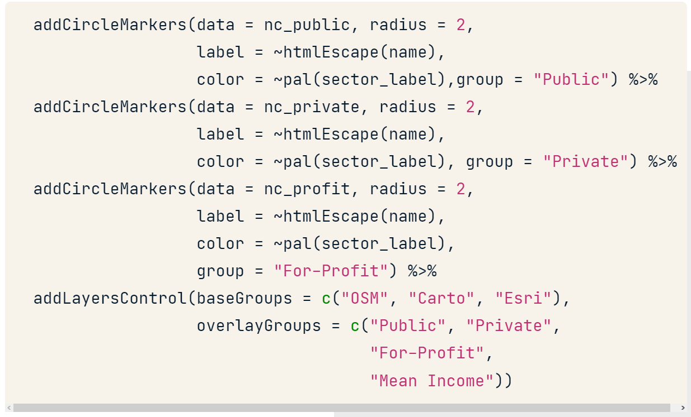

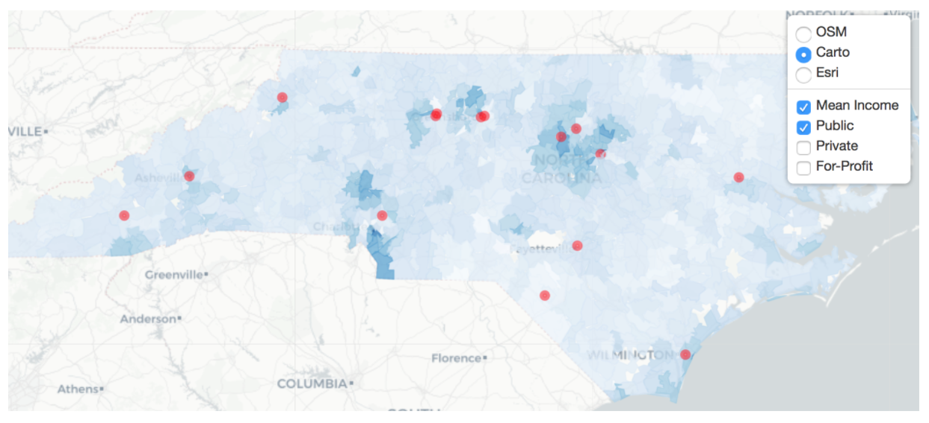

### Exporting our map to html file

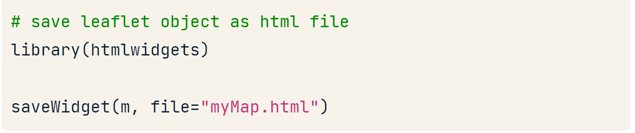

## Read spatial data

### Read vector data

Vector data can be represented as:

* Points
* Lines (points connected)
* Polygons (combinate lines)

In this type each raw of data represent a figure in our map.

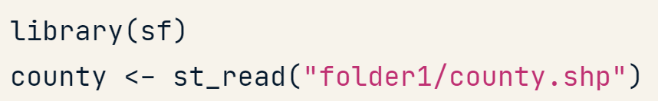

**st_read()** can be used to read in a wide range of spatial types including *shapefiles*, *geojson*, *gps*, *netcdf* and *others*.

### Read raster data

Raster data is like an photograph with many pixels and has limited zoom quality.

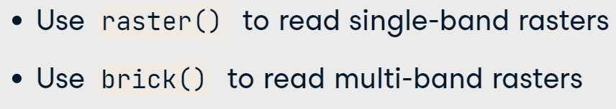

*Single-band rasters* are the simplest, these have a single layer of raster values — a classic example would be an elevation raster where each cell value represents the elevation at that location.

*Multi-band rasters* will have more than one layer. An example is a color aerial photo in which there would be one band each representing red, green or blue light.

|  |  |
| --- | --- |
|  |  |

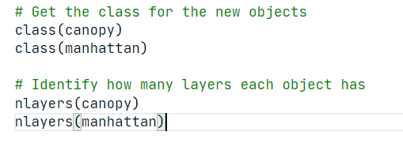

## Transforming the data

### Select and plot the vector geometry

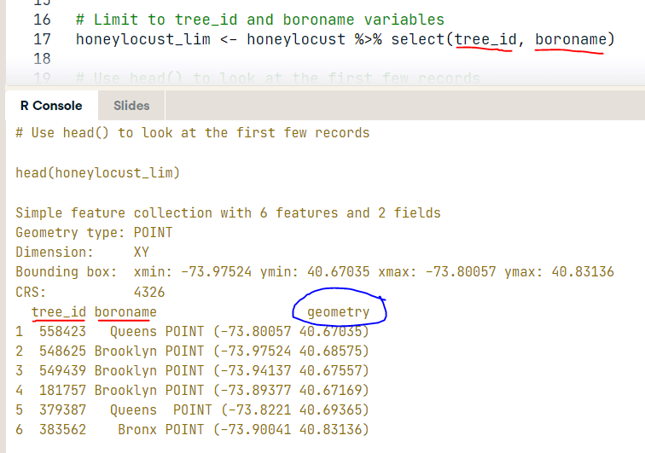

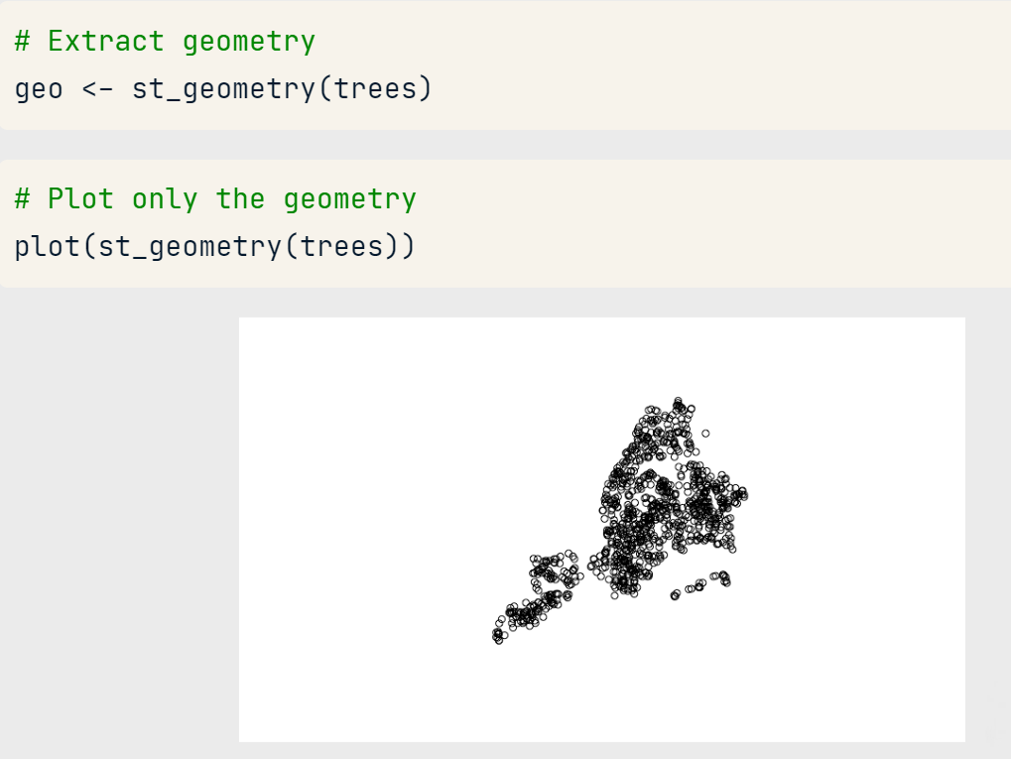

### Getting info of my sf object

**st_area():** Return a vector of class units with the area of your features.

**st_** **length():** Return a vector of class units with the length of your features.

To work with this vector we need to take out the metadata with the function **unclass(result).**

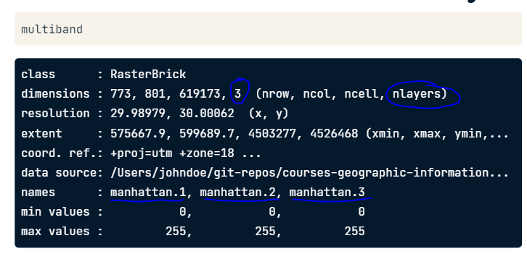

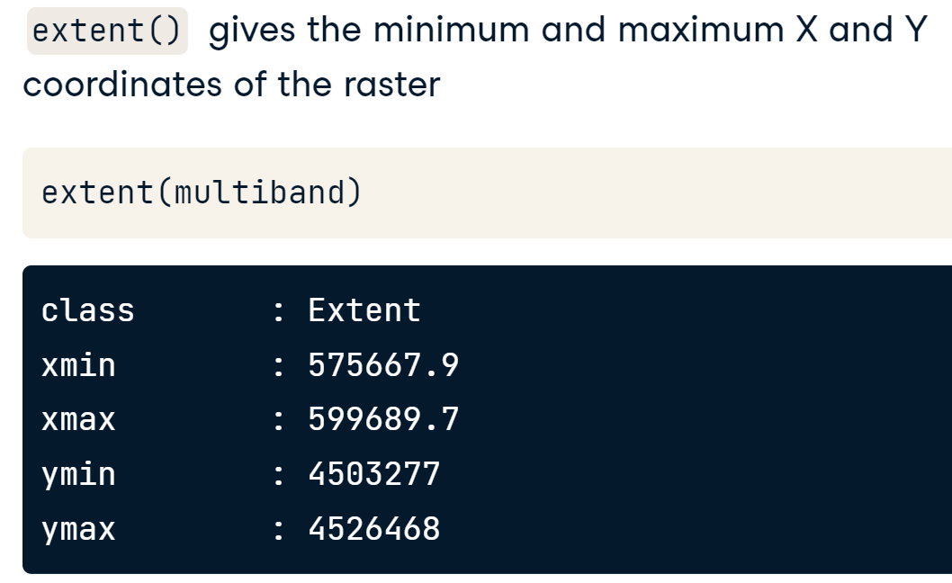

**ncell()** determines how many grid cells are in the canopy layer and the manhattan layer.

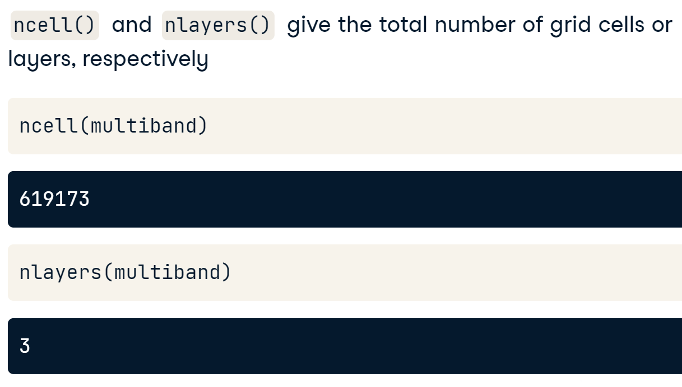

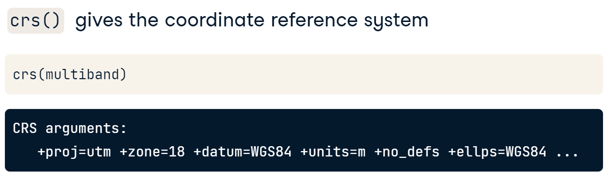

**getValues()** function on the canopy object to read in all the data.

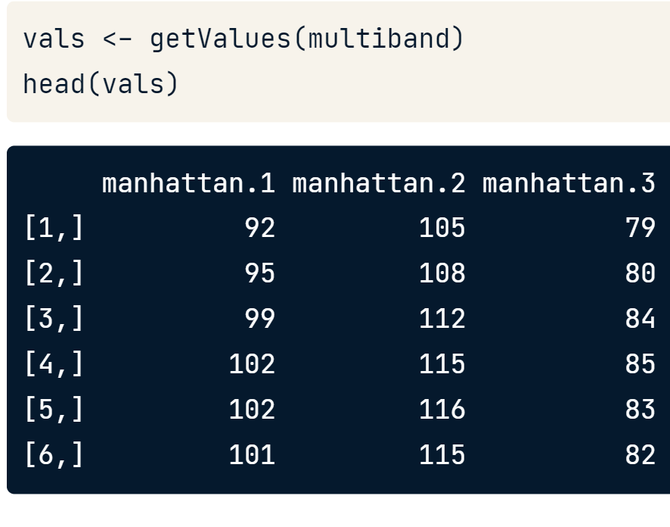

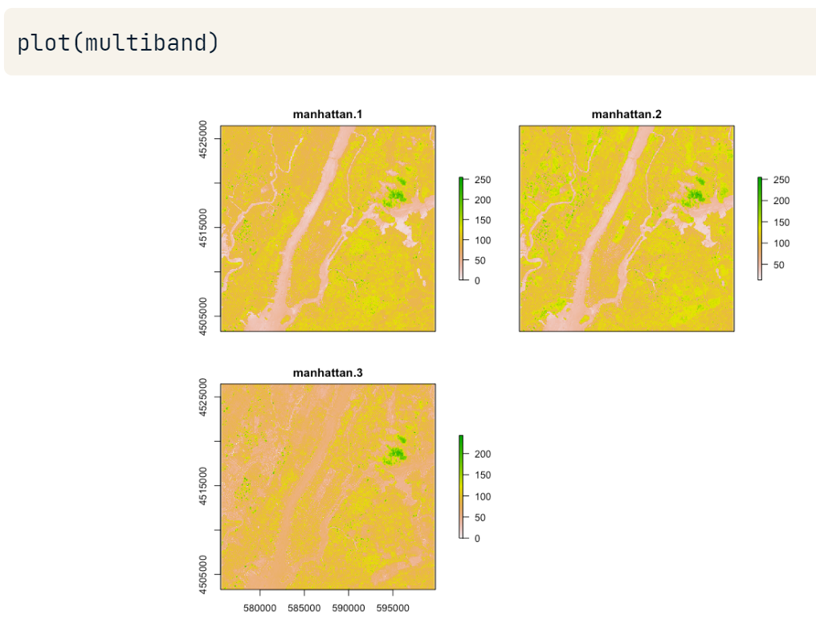

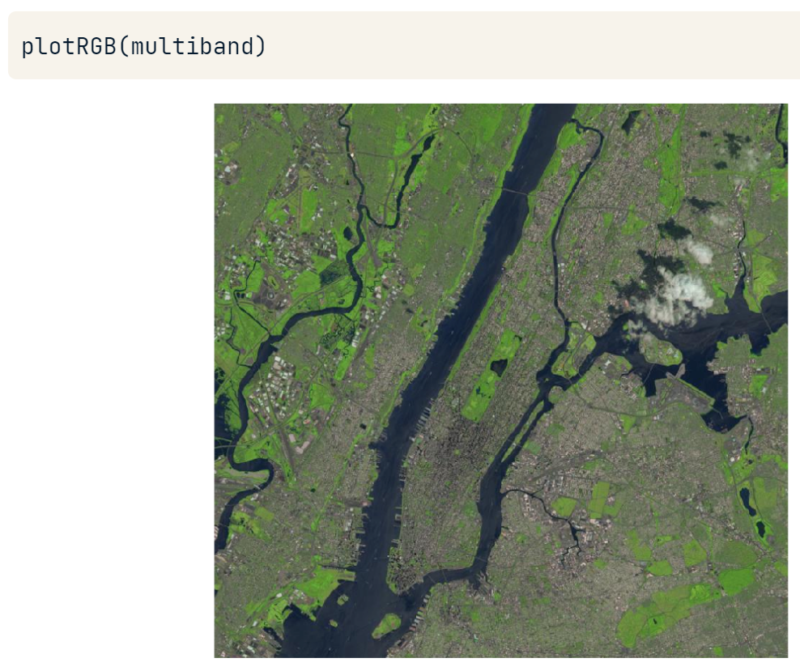

## Write spatial data

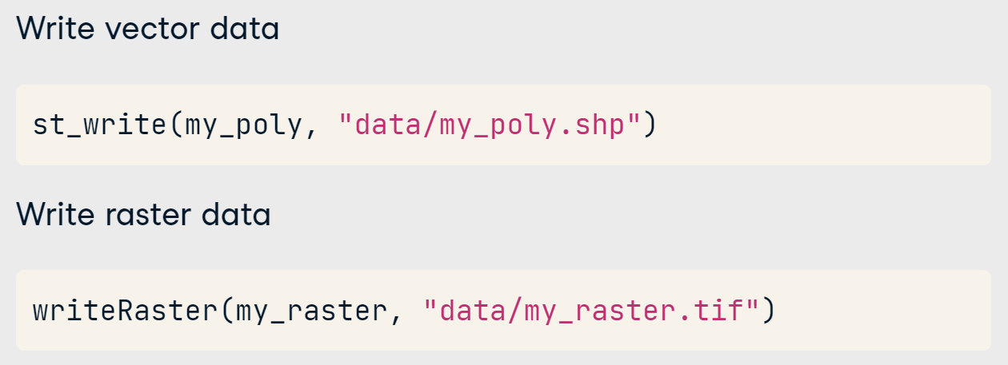

# Tidycensus

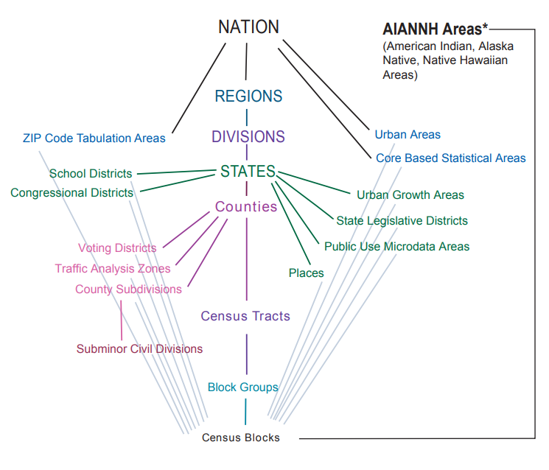



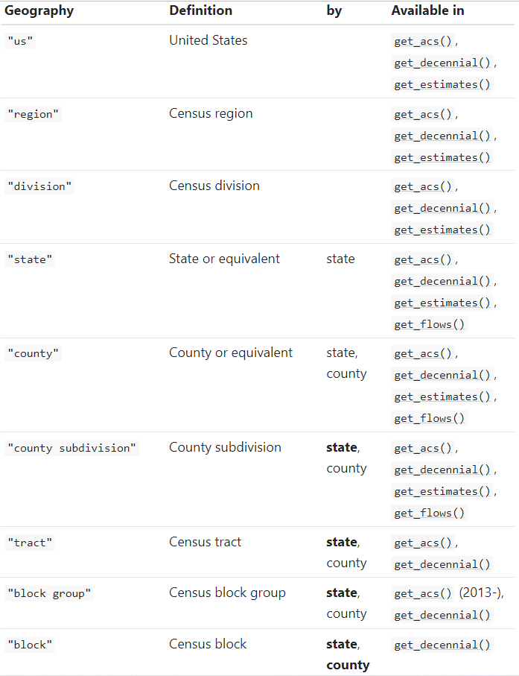

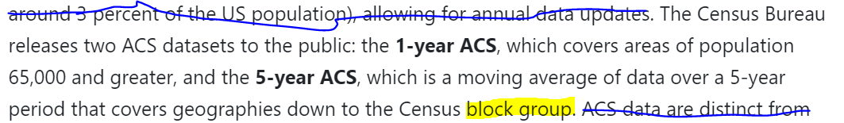

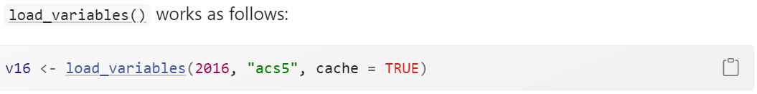



Functions to use

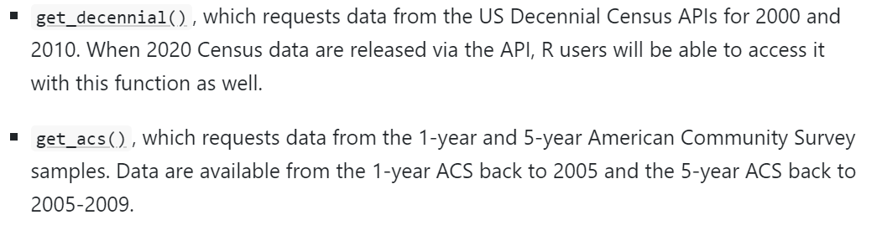

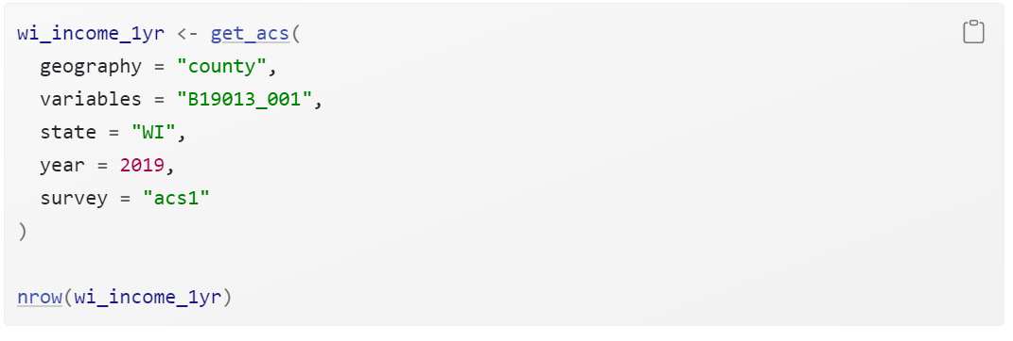

The state can be written as State Postal Codes or the State Full Name.

Rename variable in the formula

With this formula we can rename the variables and have a wider output of our request.

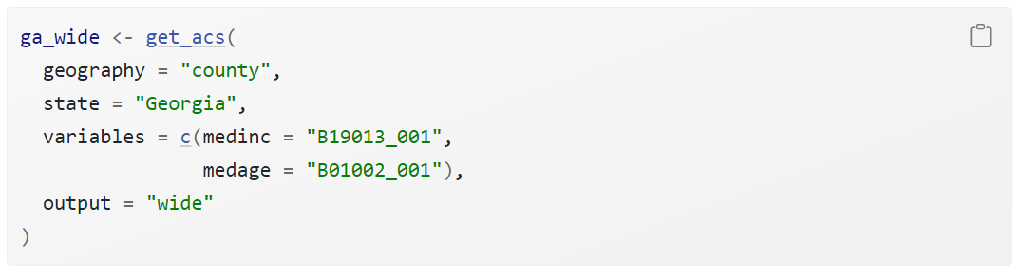

Normalizing variables

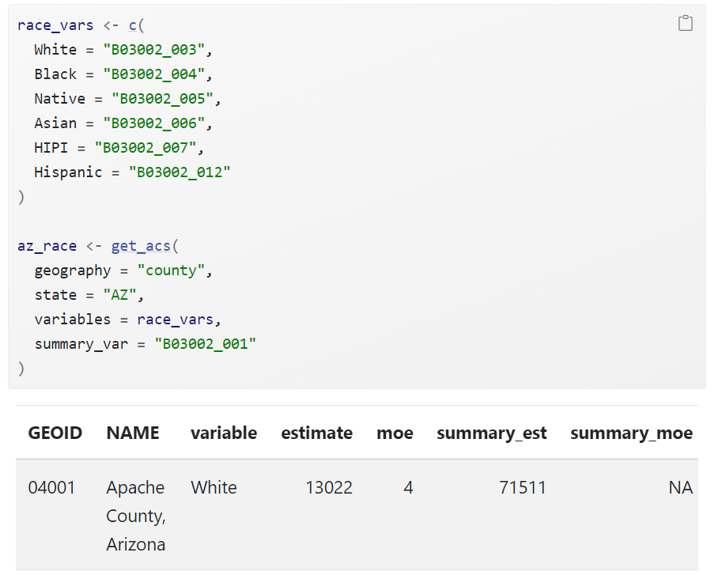

Re-coding variables

